SMART EGG INCUBATOR GUIDE
(Hatchability > 80%)

Home Page / Home
Smart Egg Incubator Control Main View 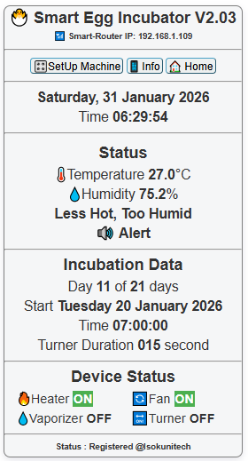
- Settings Page
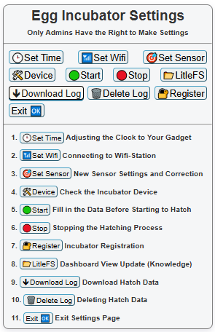

- Set Time Menu

- Set Wifi Menu
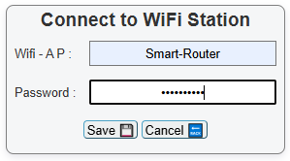
- Set Sensor Menu
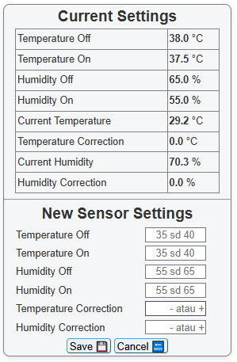

- Device Menu
To check whether the heater, fan, humidifier, egg rotating rack and buzzer are functioning normally.
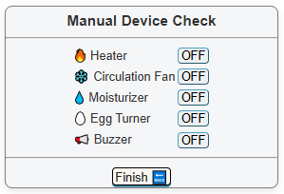
- Start Menu ( Filling in Initial Data Starting Hatching)
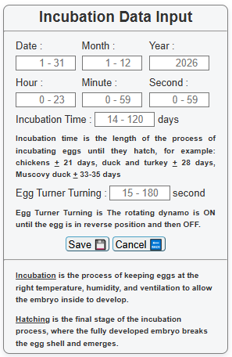
- Stop Menu (Stopping the Hatching Process - psw admin123)

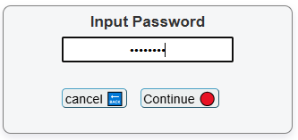

- LitleFS Menu


To make changes to the Incubator interface, only for those who understand.

- Menu Download Log

Downloading Data during 1 Incubation period process.
Or


- Delete Log Menu
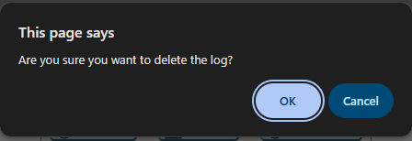

Or


- Registration Menu
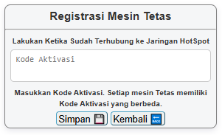
Register the Incubator with the Activation Code
(which is printed on the Incubator.)

- SetUp Machine Menu
Login Before Making Settings
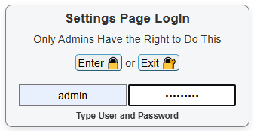
All setup processes are only carried out by Authorized Persons/Machine Psw-admin7766

Then exit

- Info Menu 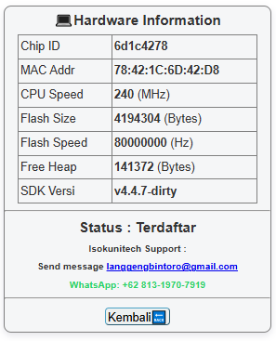
Status: Registered means the machine is ready to use.

14. Exit Menu – Return to Home Page to monitor the process

============ Have a good activity============

=========================================================================================

Get Smart Incubator Control Now!
A. Can be used with all types of racks, whether rotating, sliding, or swinging
B. Can use fan-style humidifiers or modular humidifiers
C. Modular system for easy maintenance
D. Attractive and easy-to-use features
E. Sensor set for easy calibration
F. Ensures secure and informative hatching data
G. Monitor and control the hatching process using a mobile phone or PC
H. Can be connected to the internet so you can control and monitor the hatching process from anywhere
I. Automatic heater control
J. Automatic circulation fan control
K. Automatic humidifier control
L. Egg rack control at 00, 06, 12, and 18 every day
M. Egg turning begins on the 3rd day after incubation and stops on D-3 (automatic).

